Determining the Identity and Properties of an Equilibrium Acid _{Name:}

Instructions, Chem 1212L Summer 2020
The four files you will need to complete this lab exercise are this word doc, the two csv files (data) and the mp4 video file. Start by reading through this entire document. Complete the prelab work, then watch the video of the experiment we performed for you. Record the masses from the video in the charts (in this document.) Open the csv data files in a ‘spreadsheet’ program (we recommend Excel.) Create an x, y Scatter Plot for each titration. Title and label the graphs; include them with your lab report (paste into this doc.) Complete the calculations needed to fill in the charts and answer the postlab questions.

Pre-Lab
- Define each term
  - Acid

  - Base

  - Buffer

  - Equivalence Point

  - K_{a}

  - pH

  - titration

- Explain why the pH at the equivalence point of an equilibrium acid (aka weak acid) is always greater than neutral water which has a pH= 7.

- A student weighs out 0.2500 g of an unknown diprotic acid, and uses 30.00 mL of 0.1000 M NaOH to reach the second equivalence point in titrating this acid. Show your calculations to determine the molecular weight of this acid.

Determining the Identity and Properties of an Equilibrium Acid

Objective

The purpose of this lab is to build on the experience already gained with titration reactions, and to collect and graph titration data in order to determine the molecular weight, K_{a}, and identity of an equilibrium acid.

Safety

The acids used in this lab are organic acids and represent potential hazards. Wear eye protection at all times.
All reagents can be washed down the drain with water after use.

Introduction

The auto-ionization of water is one of the basic concepts necessary to understanding acids, bases, buffers, and pH. (Equation 1)

2H₂O ⇋ H₃O+ + OH- K_{w} = 1 x 10 –14 (Equation 1)
This chemical reaction is a spontaneous process, which quickly establishes equilibrium. A reaction is said to be at its equilibrium when it proceeds in both the forward and reverse directions at equal rates, with no net change. An equilibrium constant, K, can be written for any reversible reaction. K is written as the product of the concentrations of the products, divided by the product of the concentrations of the reactants, each raised to the power of their coefficients from the balanced chemical equation. For Equation 1 above, the equilibrium expression, K_{eq}, is written:

[H 3O+ ][OH − ]
K = (Equation 2)
[H 2O]2

The concentration of the solvent, water, is considered to be unchanged as its concentration is always equal to 55.5 Molar. Therefore, equation 2 at room temperature simplifies to:

K_{w}= [H₃O+] [OH-] = 1 x 10 –14 (Equation 3)

In pure water, since the concentration of each ion is equal:

[H₃O+] = [OH-] = 1 x 10 –7 M (Equation 4)

Since the concentration of the hydroxide and hydronium ions are frequently quite small, it is more convenient to report them on a logarithmic scale; this scale is called the pH scale. Using this method, [H₃O+] is reported as pH, and [OH-] is reported as pOH.

pH = - log [H₃O+] therefore, [H₃O+] = 10-pH (Equation 5)

pOH = - log [OH-] therefore, [OH-] = 10-pOH (Equation 6)

For solutions in water,

pH + pOH = 14 (Equation 7)

Equation 7 demonstrates why the pH scale is normally limited to values between zero and fourteen. The acidity and basicity of a solution are easily measured with the pH scale; for a solution with a pH < 7.0 the [H₃O+] > [OH-] and the solution is called acidic. For a solution with a pH > 7.0, the [H₃O+] < [OH-] and the solution is called basic. A neutral solution has [H₃O+] = [OH-] and a pH = 7.0.

For this laboratory experiment, the interactions of acids and bases in a water solution will be investigated. According to the Arrhenius definition, an acid is any compound that produces a hydronium ion, H₃O+, while a base is any compound that produces the hydroxide ion, OH-.

Acid: HCl + H₂O
⎯⎯→
H₃O+ + Cl- (Equation 8)

Base: NaOH + H₂O
⎯⎯→
OH- + H₂O + Na+ (Equation 9)

Strong acids and bases react completely with water, while equilibrium acids and bases result in the establishment of an equilibrium between the acid and its conjugate base. The acid dissociation reaction is the reaction between an acid and water, for example:

HF + H₂O ⇋ F- + H₃O+ (Equation 10)
Since hydrofluoric acid, HF, is an equilibrium acid it does not react completely, but establishes an equilibrium instead. The equilibrium constant for the acid dissociation reaction is represented as K_{a} and is written as follows:

[F − ][H 3O + ]
Ka = (Equation 11)
[HF ]

The value for K_{a} is a clear indication of the relative strength of the acid; the larger the value for K_{a} the stronger the acid as it produces more H₃O+. The larger the value for K_{a}, the higher the [H₃O+]; a higher [H₃O+] results in a lower pH value since it is the negative log of [H₃O+] .

By taking the negative log of Equation 11, the following equation results.

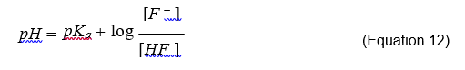

Equation 12 is called the Henderson-Hasselbalch equation, and mathematically describes a buffer system. A solution at equilibrium which contains a significant amount of a weak acid and of its conjugate base represents is called a buffer. Buffers are unique solutions because they resist changes in pH even with the addition of strong acids or bases! When a strong acid like HCl is added to the solution in equation 10, the conjugate base of HF will absorb most of the H+ ions released by the strong acid, resulting in only a small change in pH.

HCl + F- → HF + Cl- Equation 13 A similar situation occurs when a strong base is added to the same solution.
NaOH + HF → H₂O + F- + Na+ Equation 14

The capacity of a buffer is directly related to the concentration of both the weak acid and its conjugate base. The higher the concentration of the buffering molecules, the more of the other acid or base it can absorbed, referred to as the buffer capacity.

Procedural Information

In this experiment, you will use a pH probe and computer to monitor and graph the pH of a solution containing an unknown equilibrium acid in water as you titrate the acid by adding strong base. The region of most rapid pH change will then be used to determine the point where the acid has been neutralized, known as the equivalence point. Equation 15, can be used to quantify the moles of acid present, by measuring the moles of base required to reach the equivalence point. In this equation, the #eq, stands for the number of equivalents of acid or base. For example, H₂SO₄ contains two acidic protons, and will react twice for each mole of H₂SO₄ present, so its number of equivalents (#eq) is two and must be taken into account. The volume and molarity of NaOH titrant used to reach the equivalence point will be used to determine the moles of the acid initially present in solution since they are equal at this point.
M_{a}V_{a} (#eq) = M_{b}V_{b} (#eq) Equation 15 When an acid solution is titrated with a NaOH solution, the pH of the acidic solution is
initially below 7 on the pH scale. As base is added, the change in pH is quite gradual as the acid reacts with the base, until you get close to the equivalence point,

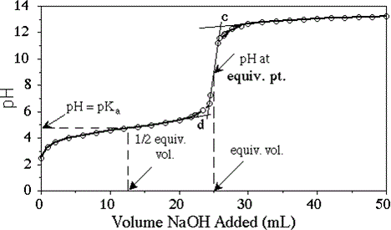

Figure 1- weak acid titration curve example

when equimolar amounts of acid and base have been mixed. Near the equivalence point, the pH increases sharply, as shown in Figure 1. Beyond this point, the change in pH then becomes more gradual again, before leveling off with the addition of excess base.

The region of least rapid pH change prior to the equivalence point will be used to determine the K_{a} of the acid. When exactly half of the acid has been reacted with the titrant base, a special situation is reached. Since half of the acid has reacted, and turned into its conjugate base, the moles of the acid remaining is equal to the moles of its conjugate base. Consider the Henderson Hasselbalch equation for this situation.

pH =
[F − ]
pKa + log ; where[F
[HF]
− ] = [HF]

pH =
pKa + log [x] ;since the log of 1=0. [x]

pH =
pKa

When titrating a weak acid a buffer system is generated during the middle portion of the titration. The buffer will react with the added base, and the pH will increase in small increments until all of the acid has been consumed. Once the acid concentration approaches zero, the pH will rise sharply through the equivalence point. It is important to realize the equivalence point does not reside at a pH of 7! The presence of the conjugate base results in the pH being greater than 7 at the equivalence point of any equilibrium acid titration. Patience will be required to prevent overshooting this point on the graph.

Materials
stirring bar
50-mL buret
ring stand
1 utility clamp
1 buret clamp
LabPro Interface
pH electrode

Computer
Solid acid unknown Phenolphthalein indicator sol’n
0.100 M NaOH solution
magnetic stirrer
wash bottle

Procedure: Titration of an unknown solid MONOPROTIC equilibrium acid with a strong base.

- Set-up the LoggerPro software with the pH probe in channel A. Open the file under Computers with Chemistry / Acid Base Titration, and ensure that the vertical axis has pH scaled from 0 to 14 pH units (make sure the pH readings display the hundredth position) and the horizontal axis has volume scaled from 0 to 50 mL. If this is not the case, try to figure it out, or ask for help

- Test the pH probe by measuring the pH of distilled water. A decent reading will be close to 7, but usually a bit lower as CO₂ dissolves in the water. If you do not get a decent reading, consult with your instructor.

- Select an unknown MONOPROTIC acid from list provided below. Each unknown contains an equilibrium acid, but they can be quite different.

- Weigh out the amount that is indicated for your unknown in the following chart, and add it to about 50 mL of dH₂O in a 250 mL beaker.

MONOPROTIC ACIDS
ID | Range for Titration (g)
15 | 0.3500-0.5000
16 | 0.4000-0.5500
17 | 0.2500-0.4000
18 | 0.0900-0.1500
19 | 0.4000-0.5500
20 | 0.5000-0.6500
21 | 0.4000-0.5500

- Add two drops of the phenolphthalein indicator to your unknown acid solution/mixture. This indicator will turn pink once all of the acid has been neutralized.

- Obtain a 50-mL buret and rinse the buret with a few mL of the ~0.1 M NaOH solution. Dispose of the rinse solution down the drain with water. Use a buret clamp to attach the buret to the ring stand as shown in Figure 2. Fill the buret a little above the `0.00-mL level of the buret with ~0.1 M NaOH solution. Drain out a small amount of NaOH solution so it fills the buret tip and leaves the NaOH at the 0.00-mL level of the buret. Record the precise concentration of the NaOH solution (given on the bottle) in your data table.

- Add enough distilled water to the beaker containing your unknown acid to submerge the exposed tip of the pH probe. Record the pH of the solution / mixture.
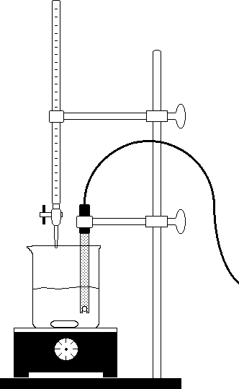
Figure 2
- Place the beaker on the magnetic stirrer and add a stirring bar. If no magnetic stirrer is available, you will need to stir with a stirring rod during the titration.

- Use a utility clamp to attach the pH electrode to the ring stand as shown in Figure 2. Position the pH electrode in the acid solution and adjust its position so that it is not struck by the stirring bar.

- Click on the COLLECT button and monitor the pH for 5-10 seconds. The pH should stabilize. If it does not, notify your instructor. Once the pH has stabilized, click on the STORE or KEEP button. The computer will hold this pH value, and wait for you to type in the buret reading. Enter the current buret reading. Click on the OK button or hit the ENTER key to store this data point. You have now saved the first data pair for this experiment.

- You are now ready to begin the titration. This process goes faster if one person manipulates and reads the buret while another person operates the computer and enters the buret readings. The actual volumes for each addition should be measured exactly every time you measure pH. Remember, slow and patient or you might miss your equivalence point. Add the NaOH in about 0.5 mL increments until the pH increases faster, then slow down.

- Continue adding NaOH until the pH changes slowly (levels off, ~ 11).

Make note of the pH if the solution turns pink.

- Save the file to a disk if you want to ensure not having to repeat any part of this lab.

Print your graph, and print your data table.
- Dispose of the beaker contents down the drain with plenty of water.
- Calculate the molecular weight of your unknown acid from your data.
- Calculate the Ka for your unknown acid from your data when the concentration of your acid is half the concentration of its conjugate base. Half way to the equivalence point.

- Compare the molecular weights, and Ka values for the unknown acids, and use these values to identify your acid.

Procedure: Titration of an unknown solid DIPROTIC equilibrium acid with a strong base. Repeat the above procedure with one of the following diprotic equilibrium acids.

DIPROTIC ACIDS
Unknown Acid | Range for Titration (g)
A | 0.1500 – 0.2000
B | 0.3000 – 0.3500
C | 0.2000 – 0.2500
D | 0.2750 – 0.3250
E | 0.4750 - 0.5250
F | 0.2000 – 0.2500
G | 0.3250 - 0.3750
H | 0.2000 - 0.2500

Data Analysis and Calculations

Monoprotic Acid Titration: From your data, determine the Equivalence point (EP) for your titration. This point on your graph has the steepest slope, i.e. the greatest change in pH for the smallest change in NaOH added. This point should be very close to where the solution turns light pink in color, indicating that the acid has been completed neutralized.

The moles of the NaOH added to reach the EP indicates the number of moles of acid weighed and added to the reaction flask.

The molecular weight of your acid is calculated by dividing the grams by the moles of the acid. The Ka value is determined from the data; the pKa = the pH at volume which is half way to the EP (see Figure 1).

Monoprotic acid | Measured Data
Unknown # | 20
Mass
# moles of acid
MW of acid
Ka value
Identity of Monoprotic
acid

Monoprotic Acid Titration | Measured Data
Concentration of NaOH
pH at the equivalence point
Volume of NaOH required to reach Equivalence point
Moles of NaOH added to reach the equivalence point
pKa value

Diprotic Acid Titration: From your data, determine the Equivalence points (EP) for your titration. Since there are two acidic protons, there will be two EP’s. These points on your graph have the steepest slopes, i.e. the greatest change in pH for the smallest change in NaOH added. Only after the second acidic proton is reacted will the solution be neutralized.

The moles of the NaOH added to reach the FIRST EP indicates the number of moles of acid weighed and added to the reaction flask.

The molecular weight of your acid is the ratio of the grams divided by the moles of the acid.

The Ka values for each acidic proton can be determined from the data. The pH = pKa at the point on the graph that is half way to the EP. For the second Ka value, K_{a2} determine the volume half way from the first EP to the second EP. The pH at this point equals pKa2. The Ka2 is calculated from the inverse log of the pKa, see Figure 2.

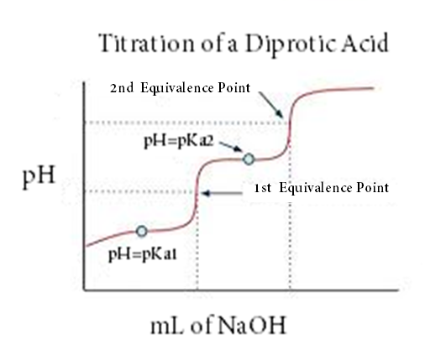

Figure 2 titration curve of a diprotic weak acid

Diprotic acid | Measured Data | Diprotic Acid Titration | Measured Data
Unknown # | A | Concentration of NaOH
Mass |  | pH at the first equivalence point
# moles of acid |  | pH at the second equivalence point
MW of acid |  | Volume of NaOH required to reach first EP
K_{a1} value |  | Volume of NaOH required to reach 2nd EP
K_{a2} value |  | Moles of NaOH added to reach the first EP
Identity of Diprotic acid |  | Moles of NaOH added to reach the 2nd EP

MONOPROTIC ACIDS
Name | MW (g/mol) | Ka
Sodium hydrogensulfate | 120.05 | 1.02 10-2
Salicylic acid | 138.12 | 1.06 x 10-3
Pyruvic acid | 88.06 | 2.8 x 10-3
Formic Acid | 46 | 1.8 x 10-4
Lactic acid | 90.08 | 8.31 x 10-4
Phenylacetic acid | 136.15 | 5.2 x10-5
Potassium binoxalate | 128.12 | 5.25 x 10-5
Benzoic acid | 122.12 | 6.28 x 10-5
Potassium Hydrogen Phthalate | 204.22 | 3.98 x 10-6
Alanine | 89.1 | 2.04 x 10-10
Glycine | 75.07 | 2.51 x 10-10
Hydrogen cyanide | 27.03 | 6.2 x 10-10
Serine | 105.1 | 7.07 x 10-10
Threonine | 119.1 | 3.72 x 10-11
Sodium bicarbonate | 84.007 | 4.68 x10-11
Sodium hydrogenphosphate | 141.96 | 4.5 x 10-13

DIPROTIC ACIDS
Name | MW (g/mol) | Ka1 | Ka2
Oxalic acid | 90.03 | 5.37 x 10-2 | 5.4 x 10-5
Phthalic acid | 166.14 | 1.12 x 10-3 | 3.91 x 10-6
Fumaric acid | 116.07 | 8.85 x 10-4 | 3.21 x 10-5
Tartaric acid | 150.087 | 9.2 x 10-4 | 4.31 x 10-5
Succinic acid | 118.09 | 6.21 x 10-5 | 2.31 x 10-6
Sodium citrate | 258.06 | 1.73 x 10-5 | 4.02 x 10-7
Maleic acid | 116.1 | 1.48 x 10 -2 | 8.51 x 10 - 7
Glutamic acid | 147.13 | 8.51 x 10- 5 | 3..38 x 10-10
Lysine Hydrochloride | 182.69 | 6.9 x 10-3 | 8.7 x 10-10
Ascorbic acid | 176 | 7.9 x 10-5 | 1.6 x10-12
Sodium dihydrogenphosphate | 119.98 | 6.32 x 10-8 | 4.5 x10-13

Post Lab Analysis Questions

- Write the balanced chemical equations for the reactions of the mono and diprotic acids with sodium hydroxide. Label the acid, base, conjugate acid and conjugate base in each reaction.

- Identify two sources of error in this experiment which may have resulted in a difference between the experimental and accepted Ka value for the equilibrium acids.

- If the Ka of hydrofluoric acid is 3.5 x 10-4. For what pH would this acid/conj. base be a suitable buffer? Explain your answer.

